

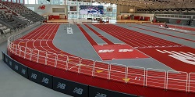

**2023 TRACK at New Balance Youth Jamboree**

**A compiled printable PDF of the completed results will be posted here at the end of the competition.**